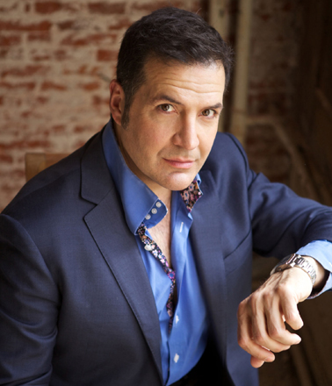
IT'S ABOUT TIME...
by Mark Janicello

“Time flies...” “Time heals all wounds..” “Living on borrowed time..” The list of sayings about time, goes on and on and on... Why are we so busy with time?

Time is generally seen as a precious commodity. The older you get, you the more you become aware that you have “less” time than you did when you were young.
The late, great Jim Croce (if you’re under 40, Google him) once sang these words...

“If I could save time in a bottle the first thing that I’d like to do.. is to save every day, ‘til eternity passes away, just to spend them with you. But there never seems to be enough time To do the things you want to do, once you find them...”

Depending on who you are, how “important” you are and how busy you are, the “hourly rate” for your precious time rises commensurately.

Strangely, even though creating a work of art is very time-consuming job, most artists, seem to have never considered how valuable time can be. I believe, that this stems from the fact that they don’t value their own time, forget about valuing anyone else’s.

How can I make a statement like that? Quite easily, actually. Now that I have replaced the T-Rex as the oldest living creature in Jurassic Park, I can speak from a sh*tload of experience.

Let’s look at how a lot of artists live. I ran three art galleries in the Netherlands. If I had an appointment with a businessman at 10:00, most of them were ready for the meeting at 9:55.
In Gallery LaRaven’s first year, we exhibited more than 60 international artists. Almost without exception, every artist was late to every single meeting I ever had with any of them. Instead of 10:00, they would saunter in at 10:20, 10:30 or even later, neither apologizing nor having bothered to call and say that they would be late.

For your information, in the New York entertainment world, there are numerous unions: AEA (Stage); SAG (Film) AFTRA (Television); and a few others. If you are working on a union contract and you are even five minutes late for a rehearsal or a shooting, by the first offense -- you get an official warning. The second time you pay a large fine. By your third offense, you get immediately fired. End of story.

There are 250,000 actors in New York City. If an actor can’t get to work on time, there are countless others, who would DIE to get that job!! Why are the unions in New York so strict? “Time is money!!!” Union filmcrews, orchestras and stagehands are extremely expensive. However, more the costs involved, being on time is a sign of respect: respect for yourself; as well as for your partner’s and/or co-worker’s time.

William Paul Young, the Canadian author of “The Shack” once wrote:

“Submission is not about authority and it is not obedience; it is all about relationships of love and respect.”

Recently, pop stars have made international headlines by arriving hours too late for their concerts. After finally arriving, neither singer offered any excuse or apology for keeping tens of thousands of people waiting. They are making millions of dollars from these concerts. Is that how you respect your business partners, your fans and your friends??

One thing is definite, the concert promoters who booked these artists are all furious. Certainly, the producers of their current tours will ALL think twice before ever working with some of them again.

Why? When a concert runs into that much overtime, it needlessly costs the concert producers enormous amounts of aggravation and money. Understand that most big international venues have union contracts, and you can only imagine how many angry ticket buyers will demand a refund.
Union performers, musicians and technicians know what their time is worth – because the unions have set guidelines for their salaries and their time.

As an visual artist, what are you worth? What is your time worth? This is the eternal question. How do you put a price tag on that? How do you know how much to charge for one of your pieces, be it sculpture, painting or installation?

There are material costs, like paint, canvas, gemstones, marble. More important than that, is putting a price tag on your original idea and the execution thereof. This is mostly determined by charging for your own time. How much of “yourself” did you invest in your creation?

Marketing can raise the “value” of your time. The better known you are, the more your works (and consequently your time) will be worth to others. Still, this is an “external” measurement.
How much is your time worth to you?? That’s the real question.

Honesty is what people see. Integrity is how you behave when no one is looking. How much personal integrity do you have as an artist?

Alone in your studio, do you value your own time, your own life? Are you wasting your life “playing at” being an artist – or do you have the personal integrity to truly be busy with creating and creation every single moment of your life?

When you have an appointment, do you show up on time? If you don’t, you’ve already got your answer.

